# **LOW FIXED RATES**

PURCHASE OR REFINANCE ● RESIDENTIAL OR COMMERCIAL

FIRST TIME HOMEBUYERS

We have many programs to choose from!

● 1st and 2nd Mortgages (80/20’s are back!) ● Condo Loans Available-careful!

● Conventional Loans: Fannie & Freddie ● Home Improvement Loans

● FHA & VA Loans (& Streamline Refi’s) ● Construction / Perm Loans

● USDA Loans – Zero Money Down ● Combine your 1st & 2nd mortgage

● Jumbo Loans – Over $726,200 ● Pristine or Challenged Credit

● STAND ALONE HELOC’S are back! ● Non-QM Loans

● Reverse Mortgages – Over 62 years young ● Hard Money < 70% LTV

● HUD $100 Down Payment Program ● Investor Rehab (Fix & Flip)

● Investment Property & 2nd Homes ● Manufactured Homes & Land

● Accurate& Accountable Closings

***Licensed Mortgage Brokerage Business***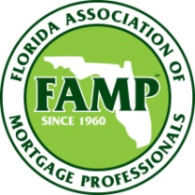

For More Information Contact:

**LISA PUSATERI**

**NMLS # 244069**

W = 813-657-8700

C = 813-310-4604

Thank You!

3419 Brook Crossing Drive

Brandon, FL 33511

**